WINDGAP ACADEMY OF LEARNING CODEBASE  
**Section 1: Homepage Animation Code (HTML + JavaScript)**

Here’s the **homepage code** with:

* Magical loading screen
* Windgap Academy building animation
* Daisy, Andy, and Winnie interaction
* Clickable “Enter Windgap Academy of Learning” button
* Toggleable music options (nature, instrumental, off)
* Consistent formatting, indentation, and naming
* Inline comments and docstrings

**📄 HTML + JavaScript (Copy-Paste Ready)**<html lang="en"></html lang="en">

  <meta charset="utf-8" ></meta charset="utf-8" >

  <meta name="viewport" content="width=device-width, initial-scale=1.0" ></meta name="viewport" content="width=device-width, initial-scale=1.0" >

  <link rel="stylesheet" href="styles.css" ></link rel="stylesheet" href="styles.css" >

  <script src="https: cdn.jsdelivr.net="" npm="" howler"=""></script src="https:>

  <div id="loadingscreen" class="loading"></div id="loadingscreen" class="loading">

    <div class="sparkle"></div class="sparkle">

    <h1 class="academy-title">🌟 Enter the City 🌟</h1 class="academy-title">

    <p class="loading-text">Preparing your journey...</p class="loading-text">

  <div id="homepage" class="hidden"></div id="homepage" class="hidden">

    <div class="academy-scene"></div class="academy-scene">

      <img src="windgap_building.png" alt="windgap academy building" class="building" ></img src="windgap_building.png" alt="windgap academy building" class="building" >

      <img src="daisy.png" alt="daisy" class="character" ></img src="daisy.png" alt="daisy" class="character" >

      <img src="andy.png" alt="andy" class="character" ></img src="andy.png" alt="andy" class="character" >

      <img src="winnie.png" alt="winnie" class="character floating" ></img src="winnie.png" alt="winnie" class="character floating" >

    <div class="music-controls"></div class="music-controls">

      🎵 Music:

      <select id="musicselector"></select id="musicselector">

        <option value="none">Off</option value="none">

        <option value="nature">Nature Sounds</option value="nature">

        <option value="instrumental">Calming Instrumental</option value="instrumental">

    <button id="enterbutton" class="enter-btn">Enter Windgap Academy of Learning</button id="enterbutton" class="enter-btn">

**Flowchart: Homepage Interaction**

flowchart TD

    A[Loading Screen] --> B[Homepage Display]

    B --> C[Character Animation]

    B --> D[Music Selector]

    D --> E[Nature Sounds]

    D --> F[Instrumental Music]

    D --> G[Music Off]

    B --> H[Enter Button Click]

    H --> I[Redirect to Dashboard]

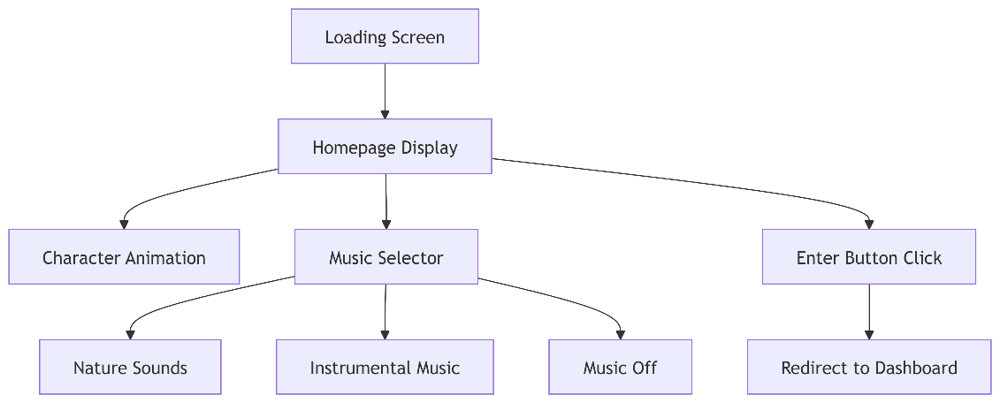

**UML Diagram: Homepage Module**

classDiagram

class Homepage {

+initHomepage()

+handleMusicSelection()

}

class Character {

+name: String

+position: Coordinates

+animate()

}

Homepage --> Character

**Copy-and-Paste Homepage Animation Code**

This code includes:

* Magical loading screen
* Windgap Academy building animation
* Daisy, Andy, and Winnie interaction
* Clickable “Enter Windgap Academy of Learning” button
* Toggleable music options (nature, instrumental, off)

**📄 HTML + JavaScript**